The Impact of Artificial Intelligence on Employment



# Cluster Innovation Centre

# University of Delhi

**AMIT | ASHUTOSH | TUSHAR**

NOV 2020

Month long project submitted for the paper of:

*History, Culture & Civilization*

# CERTIFICATE OF ORIGINALITY

The work embodied in this report entitled **“The Impact of Artificial Intelligence on Employment”** has been carried out by **Amit, Ashutosh and Tushar** for the paper of **“History, Culture & Civilization”**. We declare that the work and language included in this project report is free from any kind of plagiarism.

The work submitted is original and has not been submitted earlier to any institute or university for the award of any degree or diploma.

**Amit**

(11807)

**Ashutosh**

(11811)

**Tushar**

(11840)

# ACKNOWLEDGEMENT

With a deep sense of gratitude, we express our dearest indebtedness to **Prof. Dorje Dawa** for his support throughout the duration of our project. We would like to thank him for giving us the opportunity to do this wonderful project. His learned advice and constant encouragement has helped us complete this project. It is a privilege for us to be his students. Without his encouragement and guidance this project would not have materialized.

We are also thankful to our friends and family who helped us with their valuable suggestions and guidance that have been helpful in various phrases of the completion of the project.

# ABSTRACT

This project is designed to study the impacts of *Artificial Intelligence (AI)* on the workforce and employment. *Artificial Intelligence (AI)* is a rapidly advancing form of technology with the potential to drastically reshape world employment. In this project we will discuss the various scenarios and the effects of AI and automation on the future of work based on various factors. This study will enable multidisciplinary research to quantitatively monitor and predict the complex evolution of work in tandem with technological progress.

The main objective of this project is to study and analyze previous, current and future effects of AI on the workforce, its differential impact on different types of labor. How does the process of digitalisation transform the nature of work ? With AI’s potential to change the nature of work, how can policy makers facilitate the next generation of employment opportunities? And how AI is reshaping the jobs in various parts of the world?

Futurists predict that a third of jobs that exist today could be taken by Smart Technology, Artificial Intelligence, Robotics, and Algorithms (STARA) by 2025. However, very little is known about how employees perceive these technological advancements in regards to their own jobs and careers, and how they are preparing for these potential changes.

# 

# TABLE OF CONTENTS

1. **Introduction**
2. **Contrasting perspectives**
   1. Optimist’s perspective
   2. Doomsayer’s perspective
   3. Unifying perspectives
3. **Method of analysis**

# Genesys opinion survey

* 1. Survey of Corporate Management and Economic Policy (RIETI)
  2. Study done by Georgios Petropoulos with the assistance of Nicolas Moës

1. **Results**

# Genesys opinion survey

* 1. Survey of Corporate Management and Economic Policy (RIETI)
  2. Study done by Georgios Petropoulos with the assistance of Nicolas Moës

1. **Word cloud**
2. **Conclusion**
3. **References**

# INTRODUCTION

AI and related technologies are being heralded as *“the next big thing”*, one that promises to revolutionize many areas of economic activity and thus to have a profound impact on economic growth. However, the rise of AI coincides with a recent wave of pessimism in terms of productivity growth, expressed forcefully by prominent economists such as *Larry Summers (2016)* and more thoroughly by *Bob Gordon (2016)*.

Rapid advances in *Artificial Intelligence (AI)* and automation technologies have the potential to significantly disrupt labor markets. While AI and automation can augment the productivity of some workers, they can replace the work done by others and will likely transform almost all occupations at least to some degree.Unlike previous technologies, examples of AI have applications in a variety of highly educated, well-paid, and predominantly urban industries, including medicine, finance, and information technology.

While technology generally increases productivity, AI may diminish some of today’s valuable employment opportunities. The substitution of human labour by artificial intelligence and robots is a keenly debated topic. Some claim that a substantial share of jobs is at risk, while others argue that computers and robots will lead to product innovations and hence to unimaginable new occupations. Consequently, researchers and policy makers worry about the future of work in both advanced and developing economies worldwide. As an example, China is making AI-driven technology the centerpiece of its economic development plan. Automation concerns are not new to AI, and examples date back even to the advent of written language. In ancient Greece (ca. 370 BC), *Plato’s Phaedrus* described how writing would displace human memory and reading would substitute true knowledge with mere data.

Rapid technological progress and innovation can threaten employment. Such a concern dates back at least to the 1930s, when *John Maynard Keynes* postulated his *“Technological Unemployment Theory”* - technological change causes loss of jobs (Keynes 1937).

Technological innovations can affect employment in two main ways:

* *Displacement effect:* by directly displacing workers from tasks they were previously performing .
* *Productivity effect:* by increasing the demand for labour in industries or jobs that arise or develop due to technological progress .

*Autor, Levy and Murnane (2003)* stress that technology can replace human labour in routine tasks, whether manual or cognitive, but (as yet) cannot replace human labour in non-routine tasks. *Goos and Manning (2007)* argue that the impact of technology leads to rising relative demand in well-paid skilled jobs, which typically require non-routine cognitive skills, and rising relative demand in low-paid, least-skilled jobs, which typically require non-routine manual skills. At the same time, demand for ‘middling’ jobs, which have typically required routine manual and cognitive skills, will fall. There have been numerous studies on the complementarity/substitutability of AI and the skills of workers. Earlier studies have presented evidence based on the skill-biased nature of AI that indicate skilled labour and AI are complementary, but that unskilled labour and AI are substitutes. More recent studies have shown that AI substitutes for routine tasks conducted by middle-skilled workers, which results in the polarisation of the labour market.

*Acemoglu and Autor (2011)* found similar results for the US, while *Darvas and Wolff (2016)* report such developments for a selection of EU countries: *France, Germany, Italy, Spain, Sweden and the UK*.

## CONTRASTING PERSPECTIVES

Rapid technological progress and innovation can threaten employment. Such a concern is not new but dates back at least to the 1930s, when *John Maynard Keynes* postulated his *“Technological Unemployment Theory”* – technological change causes loss of jobs (Keynes 1937). But some other researchers argue that AI may create new employment opportunities that are currently unimaginable, and technology-intensive emerging firms may create many new occupations, thus making its way for contrasting perspectives.

## Optimist’s Perspective:

Optimists suggest that technology may substitute for some types of labor but that efficiency gains from technological augmentation outweigh transition costs and, in many cases, technology increases employment for workers who are not in direct competition with it (although recent follow-up work suggests these are temporary gains). Furthermore, the skill requirements of each job title are not static and actually evolve over time to reflect evolving labor needs.

For example, workers may require more social skills because those skills remain difficult to automate. Even if technology depresses employment for some types of labor, it can create new needs and new opportunities through *“creative destruction”* . For instance, the replacement of equestrian travel with automobiles spurred demand for new roadside amenities, such as motels, gas stations, and fast food.

## Doomsayer’s Perspective:

Technology improves to make human labor more efficient, but large improvements may yield deleterious effects for employment. This obsoletion through labor substitution leads many to worry about *“technological unemployment”* and motivates efforts to forecast AI’s impact on jobs. One study assessed recent developments in AI to conclude that 47% of current US employment is at high risk of computerization, while a contrasting study, using a different methodology, concluded that a less alarming 9% of employment is at risk.

Similar studies have looked at the impact of automation on employment in other countries and reached sobering conclusions: Automation will affect 35% of employment in Finland, 59% of employment in Germany, and 45 to 60% of employment across Europe. Critics have complained that prospective studies lack validation, but retrospective studies also find that AI is diminishing employment opportunities in US manufacturing.

## Unifying Perspectives:

On one hand, multiple dynamics accompany technological change and create uncertainty about the future of work. On the other hand, experts agree that occupations are best understood as abstract bundles of skills and that technology directly impacts demand for specific skills instead of acting on whole occupations all at once.

Therefore, a detailed framework that connects specific skill types to career mobility and to whole urban workforces may help to unify competing perspectives. Existing studies have argued theoretically that different skill types underpin aggregate labor trends, such as job polarization and urban migration, but robust empirical validation is made difficult by the specificity of modern skills data and their temporal sparsity.

## 

# METHOD OF ANALYSIS

The data used in this paper originate from three studies which are :

* *Genesys opinion survey*
* *Survey of Corporate Management and Economic Policy (RIETI)*
* *The Impact Of Artificial Intelligence on Employment by Georgios Petropoulos*

# Genesys opinion survey

A nationwide online - survey was conducted by *Genesys* in *April 2019* which included 1,001 currently employed U.S adults over the age of 18. They were asked about the current and future effects of AI in the workplace. Participants across industries were asked to select the three jobs most likely to be replaced by AI from among the following options:

* *Accountant/Tax Preparer*
* *Data Entry*
* *Food Service*
* *Insurance Underwriters*
* *Manufacturing*
* *Paralegal*
* *Pharmacist*
* *Retail/Checkout Clerk*
* *Telemarketer*
* *Transportation/Driver*
* *Others*

## Survey of Corporate Management and Economic Policy (RIETI)

This survey was conducted from *October to December 2015* to a variety of *public and private Japanese firms* operating in both manufacturing and service industries. A total of 3,438 firms responded to the survey (response rate was 22.9%). The breakdown of firms by industry are as follows:

* *Manufacturing 1,647 (48.1%)*
* *ICT 199 (5.8%)*
* *Wholesale 639 (18.6%)*
* *Retail 403 (11.8%)*
* *Services 395 (11.5%)*
* *Other industries 144 (4.2%)*

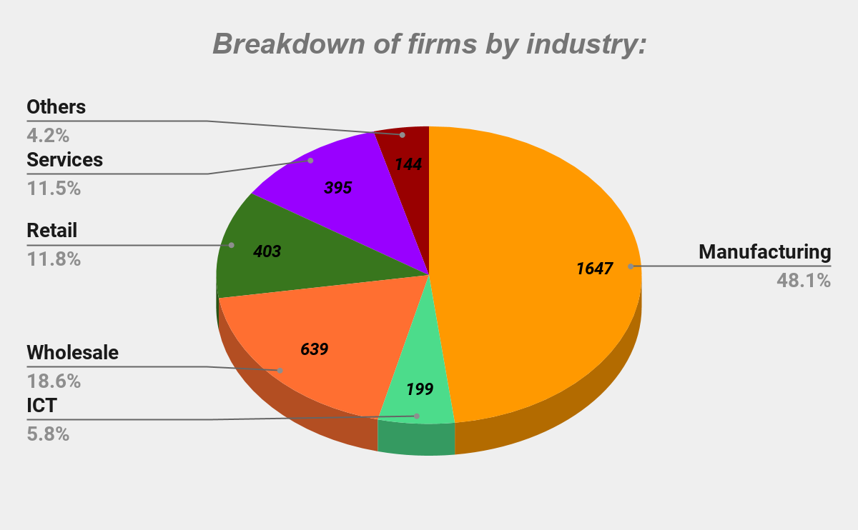

**Fig. 1:** Pie chart showing breakdown of firms by industry.

The survey inquiry was wide-ranging, but in this project, we have focused on basic firm characteristics available from the survey, such as industry, firm size (total number of employees), and employee composition. The survey included three multiple choice questions that were used to study the effect of AI on employment.

Data is the lifeblood of AI**.** The first question was regarding the use of Big Data: **“How does your firm think about Big Data?”**. The four possible responses were:

* *“already using for business,”*
* *“intend to use future business,”*
* *“not related to our business,”*
* *“don’t have any idea.”*

We should note that although AI is not a prerequisite for using Big Data, AI and Big Data are complementary in business applications. That is, the availability of Big Data will enhance the use of AI on one hand, and the progress of AI technologies will accelerate the accumulation of Big Data on the other hand.

The second question investigates the possible impact of AI and robotics on businesses: **“How does your firm think about the impact of the development and diffusion of AI on the future business of your firm?”**. The five possible responses were:

* *“significant positive*
* *“positive impact,”*
* *“neither positive nor negative,”*
* *“negative impact,”*
* *“significant negative impact.”*

The third question investigates the possible impact of AI on employment: **“How does your firm think about the impact of the development and diffusion of AI and robotics on the future employment of your firm?”**. The four possible responses were:

* *“increase in the number of employees,”*
* *“decrease in the number of employees,”*
* *“no impact on the number of employees,”*
* *“don’t have any idea.”*

In this study, tabulation results of the questions were reported and answers were cross-tabulated with firm characteristics, such as industry, firm size, and workforce composition. Next, simple ordered-probit estimations were built to compare firm characteristics to their attitude regarding AI.

The firm characteristics used as explanatory variables include :

* *Industry (manufacturing, ICT, wholesale, retail, services, and other industries)*
* *Firm size (log number of employees)*
* *Geographic market area of the firms*
* *Products/services*
* *Existence of labor unions.*

The industry and the geographic market area are dummy variables: manufacturing industry and city are used as reference categories. Due to fierce competition in the development and use of AI-related technologies world-wide, firms engaged in global markets tend to have positive attitudes toward the business application of AI-related technologies.

It is important to note that the survey collects rich information regarding the characteristics of the firms’ employees. Specifically, the employees’ education - the ratio of employees graduated from university or more and the ratio of employees holding postgraduate degrees as the subset of average age, female ratio, and the ratio of non-standard workers are surveyed. The association between employee characteristics and the firms’ attitude to AI-related technologies have been analyzed in this survey. The Attitude of firms has been hypothesized with many employees that have complementary skills with AI-related new technologies will be positive toward the impacts of the new technologies. Conversely, firms with many low skilled employees would give negative views about the impacts of the development and diffusion of AI-related technologies on their business and employment.

## Study done by Georgios Petropoulos with the assistance of Nicolas Moës:

A new wave of automation and advanced machine-learning techniques is on its way, in which intelligent machines will be increasingly capable of carrying out high-skill and possibly non-routine tasks. Moving from the efficiency gains in online trading to the extensive use of artificial intelligent systems in the industrial production, concerns about the potential displacement of labour emerge.

This study examines the most important question: **Which of the two labour market effects – displacement or productivity – will dominate in the artificial intelligence (AI) era?**

Three approaches has been used to answer this question :

* *Examine the impact of technological breakthroughs on labour markets in previous industrial revolutions:*

For example: the introduction of automobiles in daily life led to a decline in horse related jobs, but new industries also emerged, with a net positive impact on employment. The automobile industry itself grew fast, creating many new jobs, but other sectors also grew because of the growing number of vehicles on the roads, and many new jobs in the motel and fast-food industries arose to serve motorists and truck drivers.

In general, past industrial revolutions suggest that in the short run the displacement effect may dominate. But in the longer run, when markets and society are fully adapted to major automation shocks, the productivity effect can dominate and have a positive impact on employment.

Researchers from the *McKinsey Global Institute* estimate that the disruption of society caused by AI is happening 10 times faster and at 300 times the scale of the industrial revolution of the late 18th and early 19th centuries, and is therefore having roughly 3,000 times the impact. Moreover, the main engine of technological progress in the AI era is the continuous development of deep machine-learning techniques that use the function and complexity of the human brain as a model for design

* *Assess the risk of occupations and tasks to be automated in the next decades because of AI systems:*

In this, the feasibility of automating existing jobs have been focused given current and presumed technological advances. *Frey and Osborne* famously claimed that *47% of US occupations* were at risk of being automated “over some unspecified number of years, perhaps a decade or two”. *Bowles (2014)* repeated these calculations for the *European labour market*, and found that on average *54% of EU jobs* are at risk of computerisation.

By contrast, *Arntz, Gregory and Zierahn* argue that a major limitation of *Frey and Osborne* is that they focus on deriving predictions over occupations as being threatened by automation rather than tasks. Their criticism is that in this way *Frey and Osborne* overestimate the automation risks. By using information on task content of jobs at the individual level they conclude that only *9% of US jobs* are potentially automatable.

*Bessen’s (2017)* empirical research found that computer technology is associated with job growth that is particularly observable in non-manufacturing industries. At the same time there are potential sector spillover effects: as *Acemoglu and Restrepo (2016)* illustrate in their theoretical model, that impacts of new technologies depend not only on the industries in which they operate, but also on adjustment in other parts of the economy.

* *Assessing the impact of AI on employment*:

Sectors and occupations might expand to absorb the labour freed from the tasks that are now performed by machines, Therefore, most research now adopts the equilibrium impact of automation on employment and wages. These all studies focus on one automated technology, the industrial robots and their impact on employment.

# RESULTS

## Genesys opinion survey:

The results from Genesys opinion survey showed that *U.S. employees* working in *education/training* and *doctor/nurse/caregivers* were the least afraid that AI/bots would take their jobs within the next 10 years. Meanwhile, those in the *media* and those with *assembly line/manufacturing* jobs were the most afraid.

Human resources employees identified *data entry* and *retail/checkou*t jobs as the most likely to be replaced by AI, and equally at risk. Employees working in *customer service*, which tend toward pessimism, the study said, chose the jobs of *retail/checkout clerk* and *telemarketer* as the most likely to suffer from AI.

Across age groups, U.S. employees believe that paralegals (4%), insurance underwriters (5%), and pharmacists (7%) have the best chance to survive automation. More part time employees (25%) fear that AI will take their jobs within 10 years compared to full-time workers (18%), although there is no significant difference in attitudes on the specific jobs they think are likely to disappear.

Employees at the largest companies (with more than 20,000 staff) are slightly less afraid (17%) than the overall group (19%) about the effect of AI/bots on their jobs, possibly because they have already experienced its negative impact (10%), and see a more stable future.

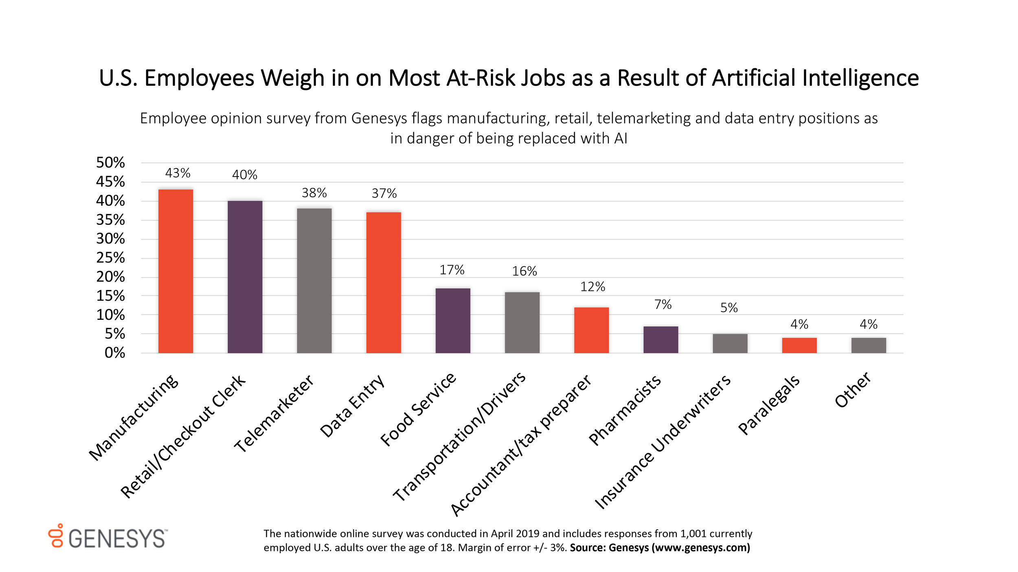

**Fig. 2:** Responses from 1001 currently employed US adults *(April 2019)*

**Source:** *Genesys* (<https://www.genesys.com/>)

## Survey of Corporate Management and Economic Policy (RIETI):

The perception of the impact of AI on employment is generally negative: 21.8% of firms responded that the development and diffusion of new technologies will decrease the number of their employees, and the share of firms expecting positive effects on their employment is notably small (3.7%). However, 28.6% of firms expect no impact of AI on their employment and 45.8% of firms responded as “don’t have any idea.”

**Table showing Impact of AI on employment:**

| ***Industry*** | ***(1) Increase*** | ***(2) No impact*** | ***(3) Decrease*** | ***(4) Don't have any idea*** |
| --- | --- | --- | --- | --- |
| ***Manufacturing*** | 3.0% | 21.8% | 29.3% | 45.9% |
| ***ICT*** | 15.9% | 30.7% | 13.8% | 39.7% |
| ***Wholesale*** | 2.0% | 30.7% | 13.9% | 53.4% |
| ***Retail*** | 1.9% | 37.8% | 16.8% | 43.6% |
| ***Services*** | 6.7% | 42.3% | 14.2% | 36.8% |
| ***Other*** | 0.7% | 33.3% | 15.6% | 50.4% |
| ***Total*** | 3.7% | 28.6% | 21.8% | 45.8% |

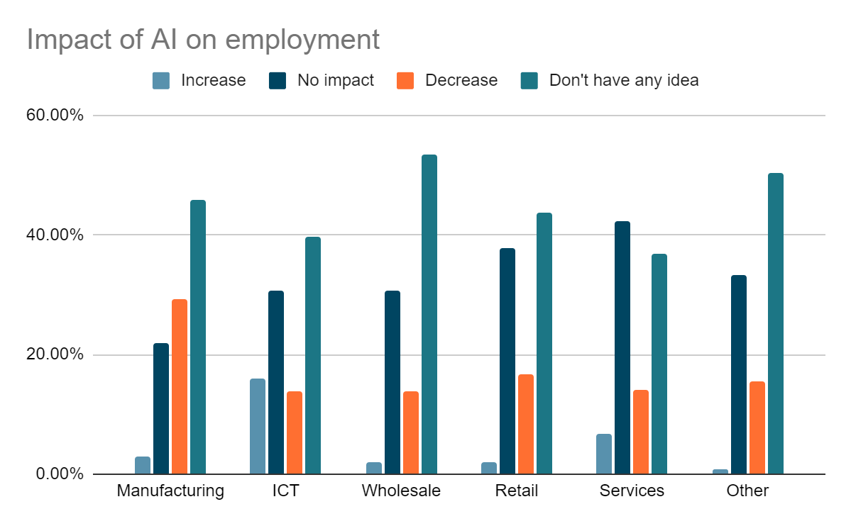

**Fig. 3:** Impact of AI on employment

By industry, with an exception of the *ICT industry*, the number of firms expecting a negative employment effect is larger than those expecting a positive employment effect. However, as mentioned in the introduction, AI may create new employment opportunities that are currently unimaginable, and technology-intensive emerging firms may create many new occupations.

When cross-tabulating the results of the three questions, firms afraid of the negative impact of AI on their business tend to have negative views on their employment. It is likely that firms with relatively low-skilled employees will be affected negatively by the ongoing *“Fourth Industrial Revolution”*, and those with highly skilled employees reap the benefit of the revolution. The relationship between the attitude toward new technologies and the education level of employees were compared to analyze this technology-skill complementarity.

**Table showing firms’ attitudes on AI-related technologies & education of the employees:**

| ***A. Use of big data*** | ***Use/Want to use*** | ***Unrelated to business*** |  |
| --- | --- | --- | --- |
| Ratio of university or more (%) | 47.0 | 35.1 | *** |
| Ratio of postgraduates or more (%) | 3.9 | 1.9 | *** |
| Chart  **Fig. 4:** Use of big data | | | |
| ***B. Impact on business*** | ***Positive*** | ***Negative/Neutral*** |  |
| Ratio of university or more (%) | 39.7 | 37.1 | ** |
| Ratio of postgraduates or more (%) | 3.7 | 1.9 | *** |
| Chart  **Fig. 5:** Impact on business | | | |
| ***C. Impact on employment*** | ***Increase/Neutral*** | ***Decrease*** |  |
| Ratio of university or more (%) | 39.1 | 33.1 | *** |
| Ratio of postgraduates or more (%) | 2.4 | 2.1 |  |
| Chart  **Fig. 6:** Impact on employment | | | |
| **Note:** ***\*\*\**** *and* ***\*\**** *indicate statistical significance at the 1% and 5% levels, respectively.* | | | |

The ratios of *university graduates* and *postgraduate degree holders* of firms using AI are 11.9% points and 1.9% points higher than the ratios of firms responding that Big Data is unrelated to their business, and the differences are both statistically significant at the 1% level. Similar relationships can be observed regarding firm attitudes toward the impact of AI on business. Firms expecting positive outcomes on their business have significantly higher ratios of university graduates (2.5% points) and employees with *postgraduate degrees* (1.8% points) than other firms. Conversely, the ratio of *university graduates* is 5.9% points lower among firms that anticipate a negative impact from AI and robotics on their employment than those expecting positive or neutral impacts. To summarize, these results suggest complementarity between new *AI-related technologies* and *employees’ skill levels.*

Interest in the development and application of AI is not limited to *Japan*, and fierce international competition is expected in this new frontier. Firms selling their products/services globally tend to exhibit positive attitudes toward AI. 25.2% of firms have positive attitudes regarding the use of AI, and 28.6% of firms expect AI to positively impact their business operations in global markets. These figures are higher than those for firms with non-positive attitudes (17.4% and 15.7%, respectively), and the differences are both statistically significant at the 1% level. 21.4% of firms expecting a positive impact on their employment engage in global markets, which is higher than the figure for firms of non-positive expectations (18.6%), and the difference is statistically significant at the 5% level.

**Table showing ratio of firms serving global market by attitude to AI technologies:**

|  | ***Positive*** | ***Negative*** |
| --- | --- | --- |
| ***A. Use Of Big Data*** | 25.2 | 17.4 |
| ***B. Impact of AI and robotics***  ***on business*** | 28.6 | 15.7 |
| ***C. Impact of AI and robotics on employment*** | 21.4 | 18.6 |

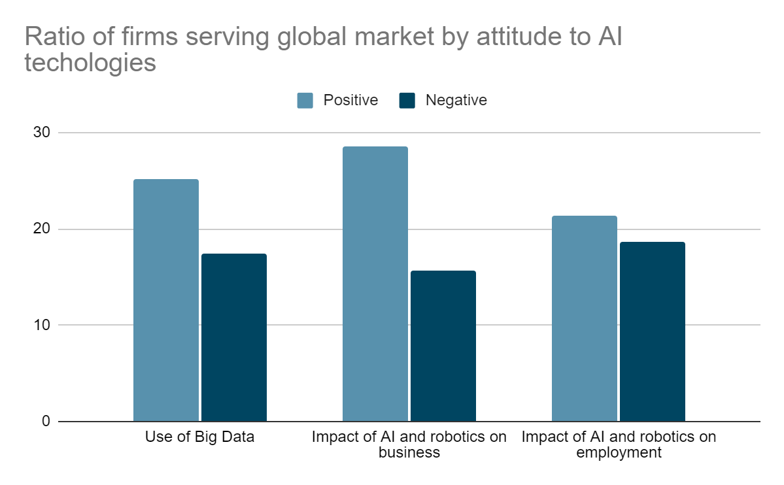

**Fig. 7:** Ratio of firms serving global market by attitude to AI technologies

## Study done by Georgios Petropoulos with the assistance of Nicolas Moës:

This study concludes the following results regarding the impact of AI on employment:

* The EU so far has been the region with the most robots in operation, followed by the US while China is behind.

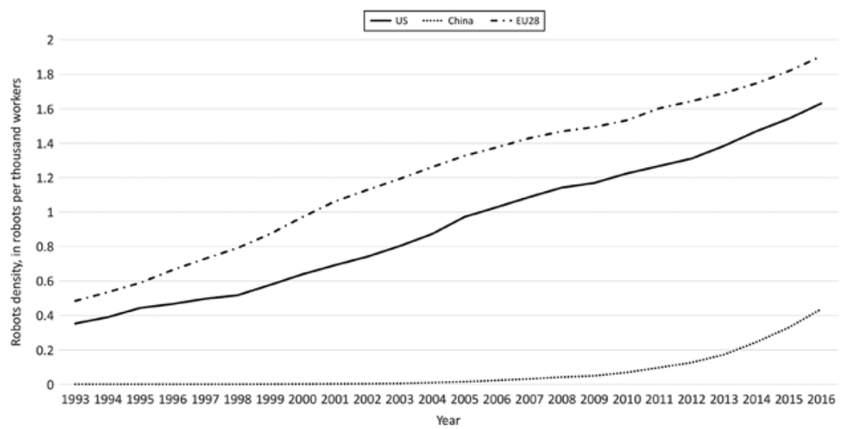

**Fig. 8:** No. of operational industrial robots per thousands of workers in China, EU and US.

* The EU automotive industry has introduced by far the most industrial robots in its production process, followed by the plastic and chemicals sector.

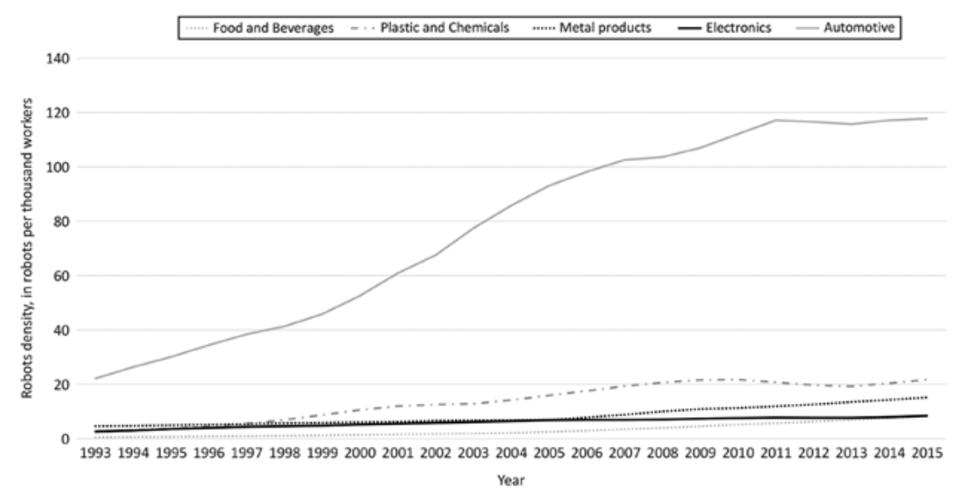

**Fig. 9:** Operational industrial robots density in different sectors in EU countries.

*Graetz and Michaels (2015)* estimate that between 1990 and 2005 the price of industrial robots in six major developed economies fell by approximately one-half or one-fifth if we adjust for the quality of robots. Moreover, between 1993 and 2007, the stock of robots per million hours worked increased by more than 150%, from 0.58 to 1.48, in 17 countries of the sample, leading to significant productivity gains.

The study also finds that in these countries increased use of robots per hour worked from 1993 to 2007 raised the annual growth of labour productivity by about 0.37 percentage points. When considering an industry-country panel specification, robots appear to reduce the share of hours worked by low skilled workers relative to middle-skilled and high-skilled workers, they do not polarise the labour market, but appear to hurt the relative position of low-skilled workers rather than middle-skilled ones.

*Acemoglu and Restrepo (2017)* used data in the post - 1990 era to show that 1 additional robot per 1,000 workers reduces the US *employment-to-population ratio* by 0.18 - 0.34% and wages by 0.25 - 0.5%. If the spread of robots proceeds over the next two decades as expected by experts, its aggregate implications for employment will be much larger. The impact of industrial robots’ penetration in local labour markets have been estimated as the labour force competes with robots for production, they exploit the heterogeneity in both local labour distribution across industries and national change in the use of robots to refine their results. Their negative result suggests that the displacement effect dominates the productivity effect of operation industrial robots. In addition, positive spillover effects are very modest. The employment effects of robots are most pronounced in manufacturing, particularly in industries most exposed to robots; in routine manual, blue-collar, assembly and related occupations; and for workers without a college education.

The study concludes that the era of AI is in its early stages and the penetration of robots in our economy and industrial production is expected to significantly rise as a consequence of the rapid, ongoing technological progress and therefore these approaches can’t be captured in its full deployment. This study can capture only some parts of the short-run effects.

# WORD CLOUD

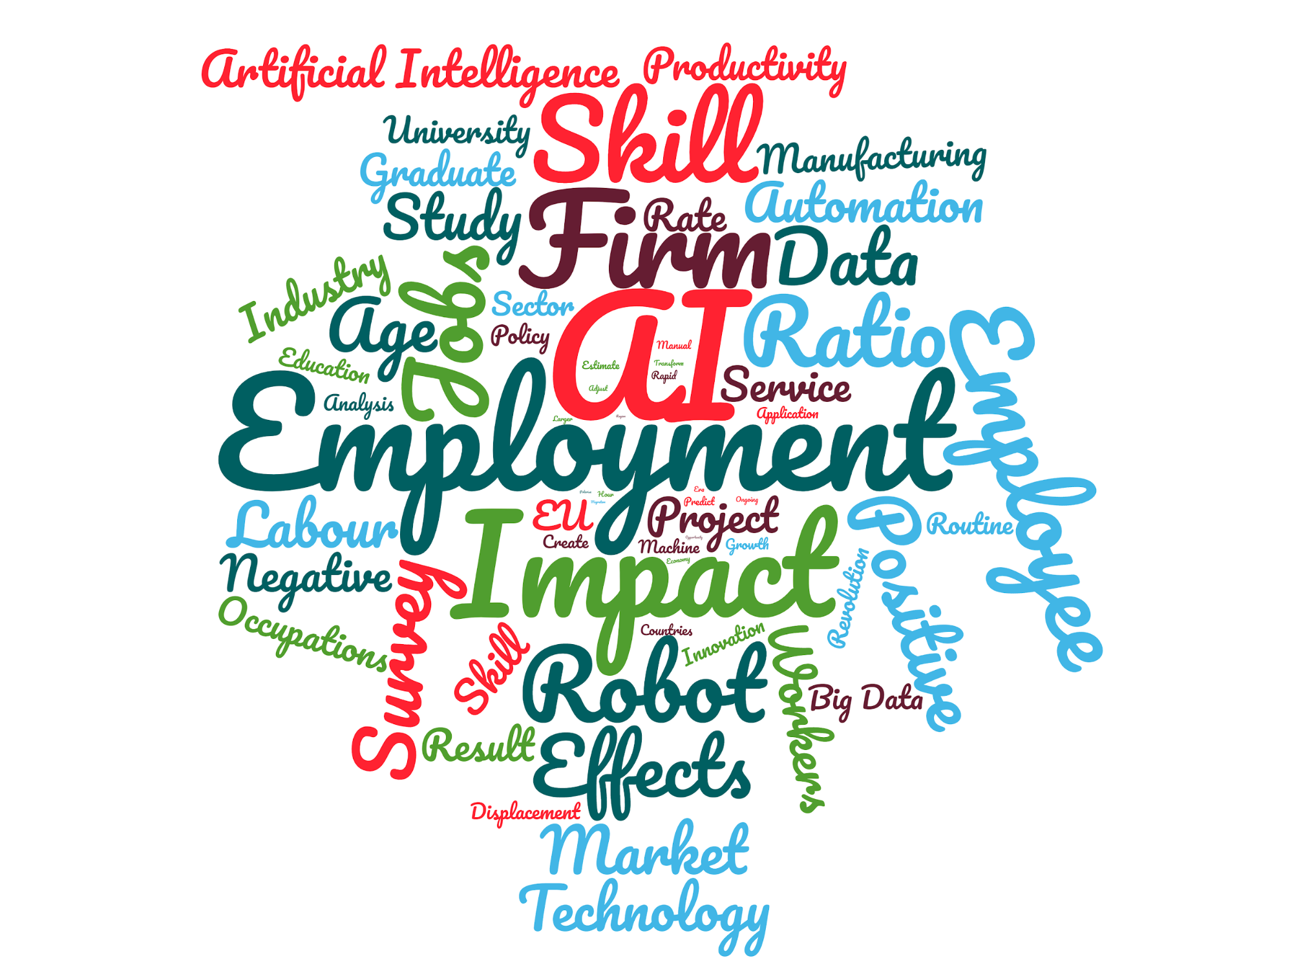

**Fig. 10:** Word cloud showing visual representation of text data used on this project, typically used to depict keyword metadata (tags) or to visualize free form text.

# CONCLUSION

This project analyzes the attitude of firms toward *Artificial Intelligence (AI)* as well as their views regarding the impacts of these new technologies on future business and employment prospects. This analysis utilizes original survey data of more than 3,000 Japanese public and private firms operating in both the manufacturing and service sectors.

Although this study is limited to simple calculations from cross-sectional survey data and the information regarding the AI-related technologies includes subjective assessments, it presents novel findings regarding this topic. The results of this study indicate the following:

* Firms operating in the service sector generally have a positive attitude toward the use of *Artificial Intelligence*. This finding suggests that we should pay attention to *“AI-using industries”* including a large number of service industries, similar to the experience from the *“IT revolution”*. Because improving productivity performance of the service sector is imperative to enhance the potential growth rate of advanced economies, diffusion and application of *AI-related technologies* in the service sector are highly expected.
* AI and the skill level of the firms’ employees are complementary. In particular, we should pay attention to the strong complementarity found at the relatively higher end of the skill distribution. This finding suggests that in order to accelerate the development and diffusion of *AI-related technologies* and, at the same time, to maintain employment opportunities, it is necessary to upgrade human capital, such as increasing the number of employees with postgraduate education.
* Firms operating in global markets reported a positive attitude toward the impact of AI-related technologies, indicating that *globalization of economic activities*, such as expanding *Economic Partnership Agreements (EPAs)*, will facilitate the development and diffusion of AI-related innovations, and active investment in utilizing these new technologies will promote further globalization of economic activities.

# REFERENCES

1. Artificial Intelligence

From: <https://plato.stanford.edu/entries/artificial-intelligence/>

<https://www.investopedia.com/terms/a/artificial-intelligence-ai.asp>

<https://en.wikipedia.org/wiki/Artificial_intelligence>

<http://sitn.hms.harvard.edu/flash/2017/history-artificial-intelligence/>

1. Fernald, J.G. (2015), “Productivity and Potential Output before, during, and after the Great Recession,” in NBER Macroeconomics Annual 2014, edited by J.A. Parker, and M. Woodford. Chicago: University of Chicago Press, 1–51.
2. Frey, C.B., and M.A. Osborne (2013), “The Future of Employment: How Susceptible Are Jobs to Computerisation?” mimeograph, Oxford Martin School.
3. Mokyr, J., C. Vickers, and N.L. Ziebarth (2015), “The History of Technological Anxiety and the Future of Economic Growth: Is This Time Different?” Journal of Economic Perspectives29, 31–50.
4. Morikawa, M. (2015), “Postgraduate Education and Labor Market Outcomes: An Empirical Analysis Using Micro Data from Japan,” Industrial Relations54, 499–520.
5. Morikawa, M. (2016), “The Effects of AI and Robotics on Business and Employment: Evidence from a Survey on Japanese Firms,” RIETI Discussion Paper, 16-E-066.

# Toward understanding the impact of artificial intelligence on labor

# From : <https://www.pnas.org/content/116/14/6531>

1. THE IMPACT OF ARTIFICIAL INTELLIGENCE ON EMPLOYMENT By Georgios Petropoulos
2. ‘Do We Understand the Impact of Artificial Intelligence on Employment?’ published by Bruegel (Petropoulos 2017a). The superb research assistance by Nicolas Moës is gratefully acknowledged
3. Acemoglu, D. and D. Autor (2011), ‘Skills, Tasks and Technologies: Implications for Employment and Earnings’, in O. Ashenfelter and D. Card (eds), Handbook of Labor Economics, vol. 4, Amsterdam: Elsevier.
4. The Economist (2016), ‘Automation and Anxiety’, The Economist, 25 June, From:<http://www.economist.com/news/special-report/21700758-willsmarter-machines-cause-mass-unemployment-automation-and-anxiety>
5. Goos, M. and A. Manning (2007), ‘Lousy and Lovely Jobs: the Rising Polarization of Work in Britain’, The Review of Economics and Statistics, 89(1): 118–33.